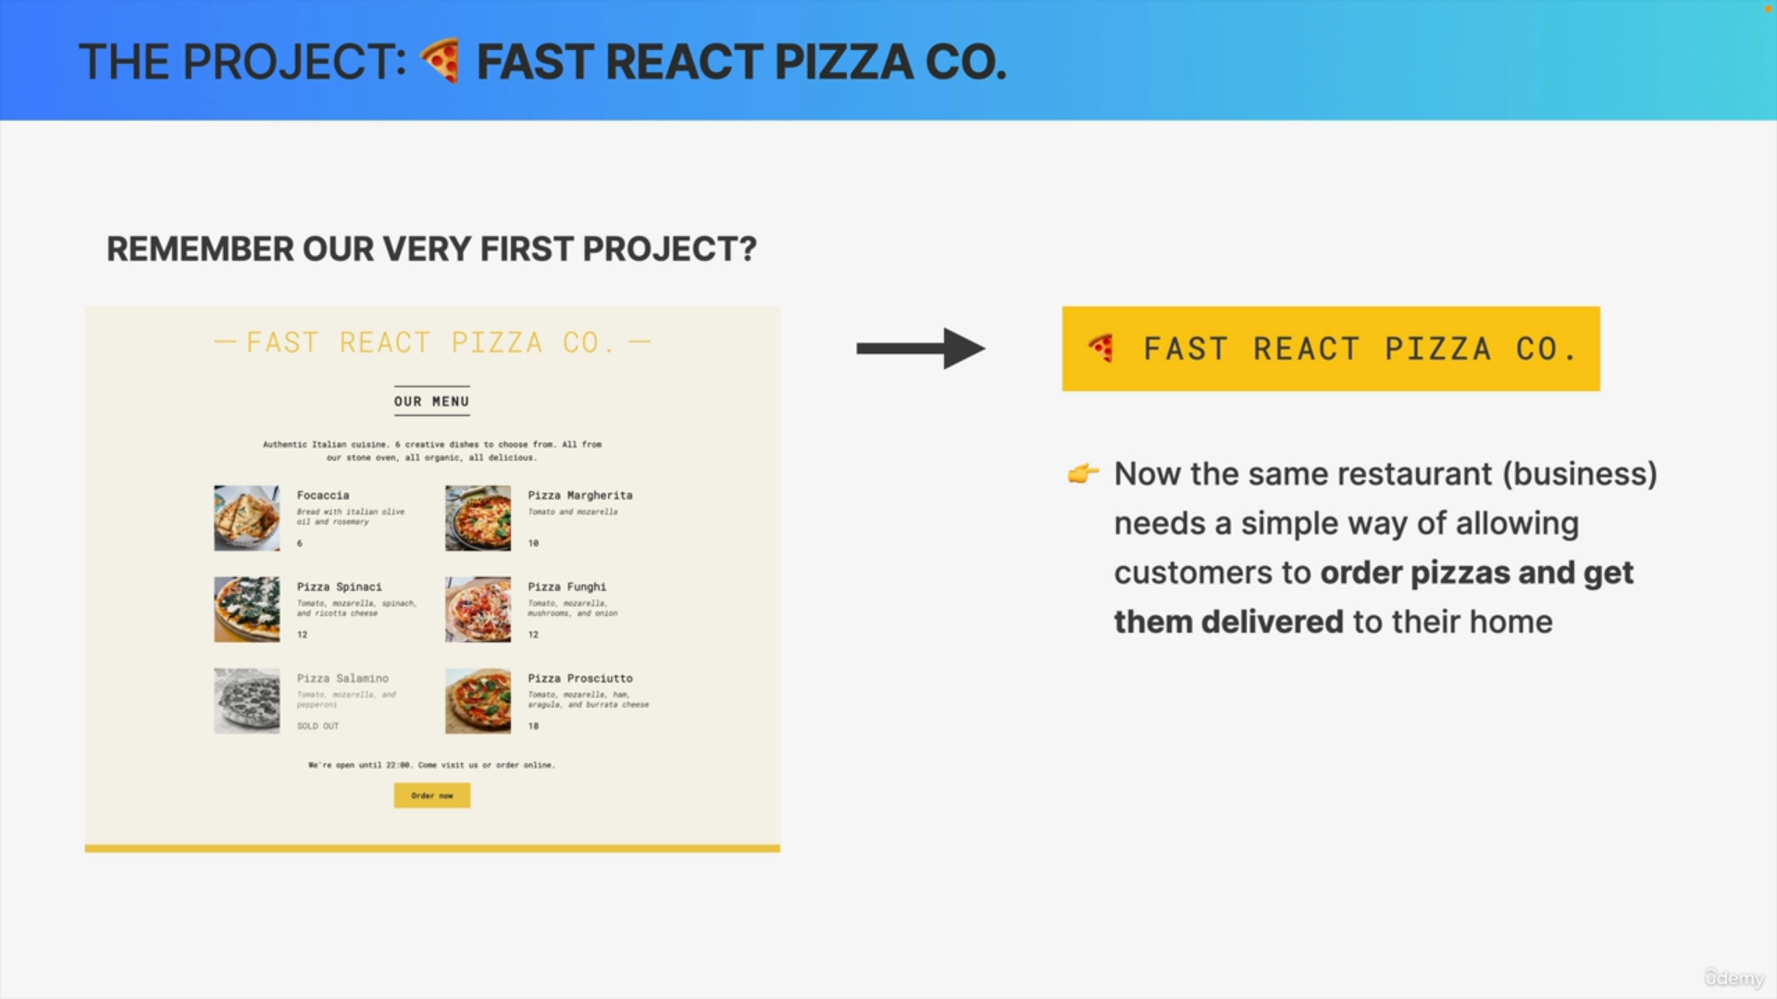

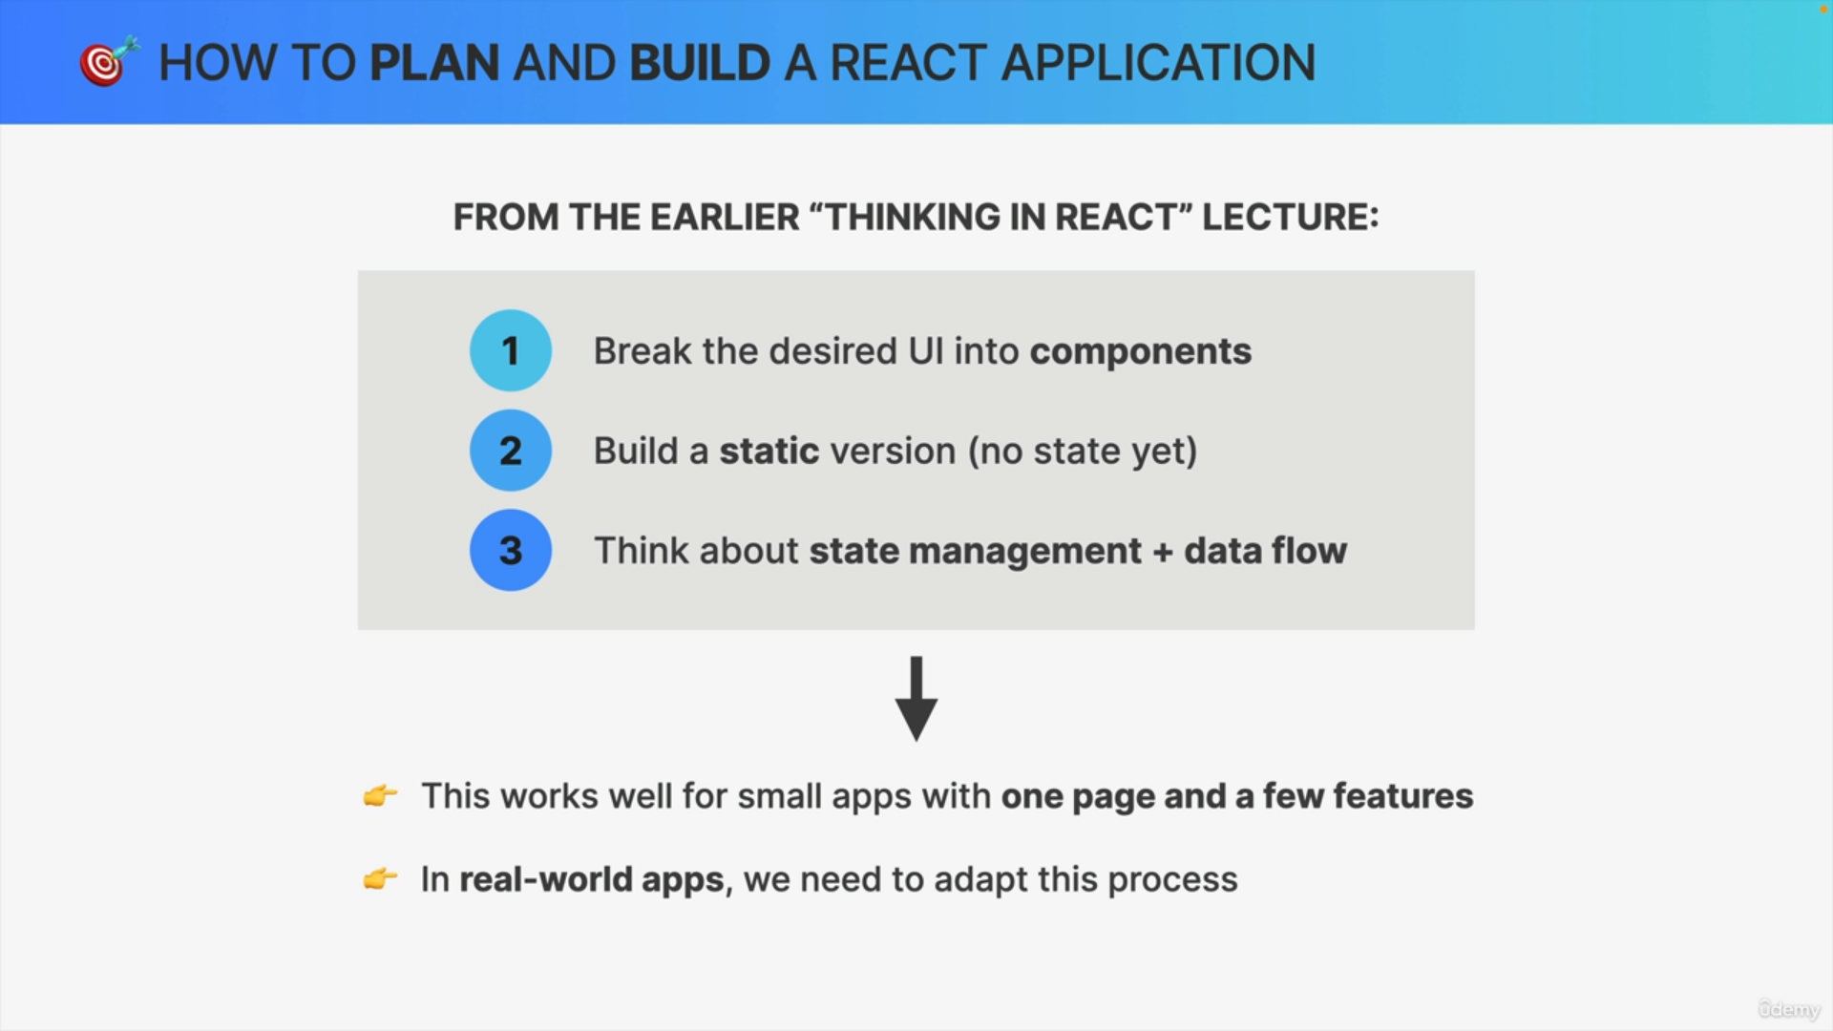

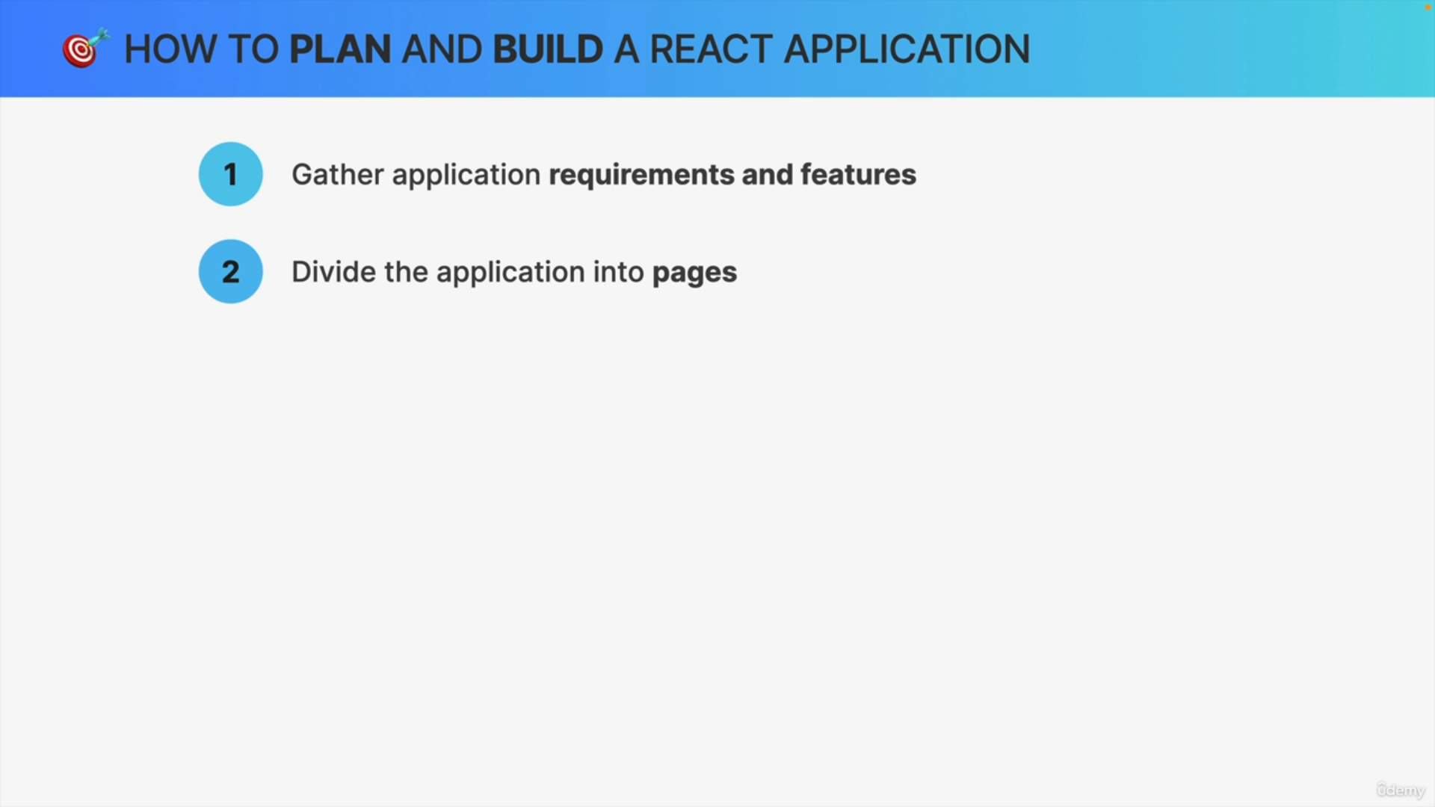

When we build a large and more real world application we need to start by gathering the application requirements and the features that the application needs and then based on those we can divide our application into multiple pages.

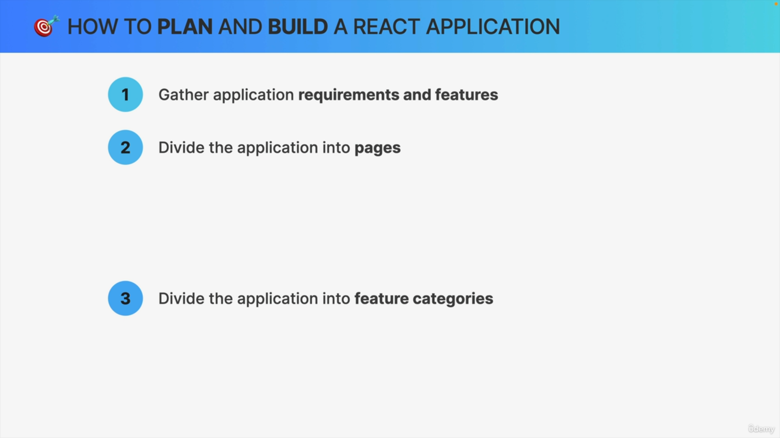

Next up, we need to divide the application and the application features into multiple feature categories, so basically we need to place all the features into a few categories, so that we can then build the application around those and so that we can organize or code any logical way.

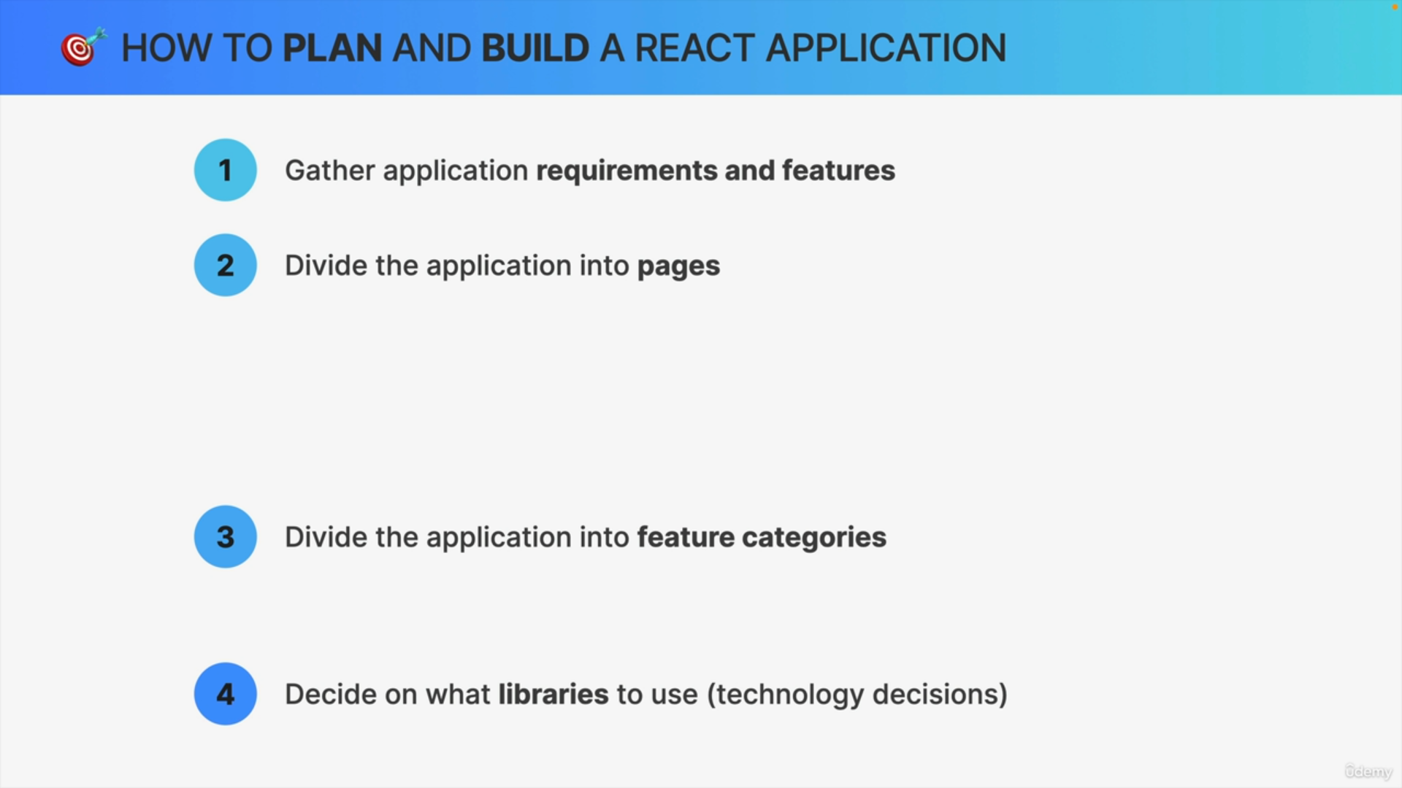

Finally, we will also need to decide on which libraries we actually want to use. So, we call this the technology decisions because this is basically where we decide exactly what tech stack we are going to use to implement our application.

